# Basic requirement

The python program temp_map.py needs the shape file (and other essential files that go with a shape file) for it to work. It also needs essential packages installed

## Shape File

The shape file (the file with the extension .shp) needs to be in the same directory with temp_map.py. It also needs at least a .shx and a .dbf file of the same name. An example for a set of files that go with the shape file may look like this:

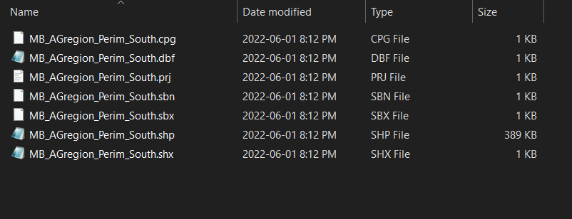

## Packages

Packages are libraries that help this python program to accomplish certain tasks. The packages this program uses are as below:

* Cartopy
* Matplotlib
* Panda
* Numpy
* Metpy
* Shapely
* Geopandas
* Cmasher
* Time

When we open our temp_map.py file using Pycharm, we will see that any packages that are not installed will have red underline. In the example below, all packages are installed except for a package called not_installed_package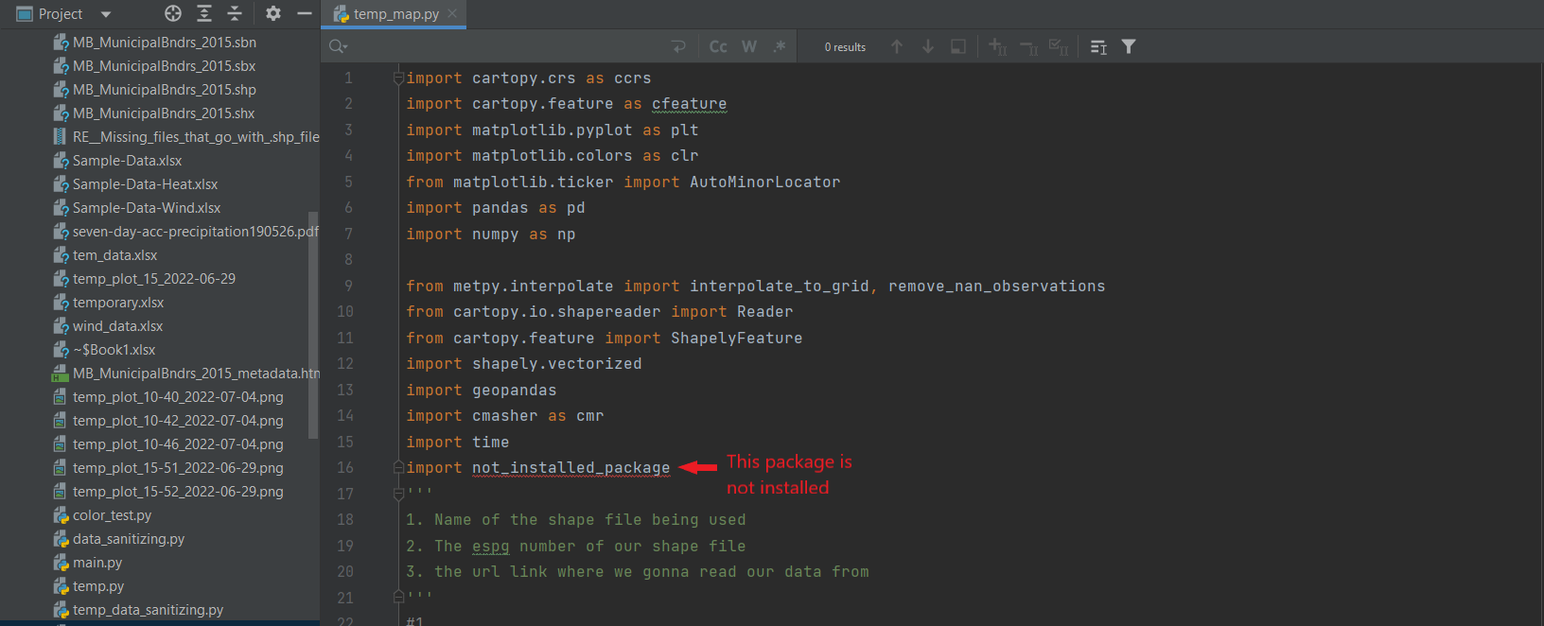

The installation of packages is machine-dependant. User needs to check if the laptop/computer they are working on have these packages installed (simply check by opening temp_map.py with Pycharm). If any packages are missing, user could install it with pip install

### 1.2.1. Pip install

**NOTE**: DO NOT use pip install to install Cartopy, shapely and geopandas

Most of the packages can be installed directly with pip install (on windows), accepts for Cartopy, shapely and geopandas (more details in 1.2.2). To use pip install:

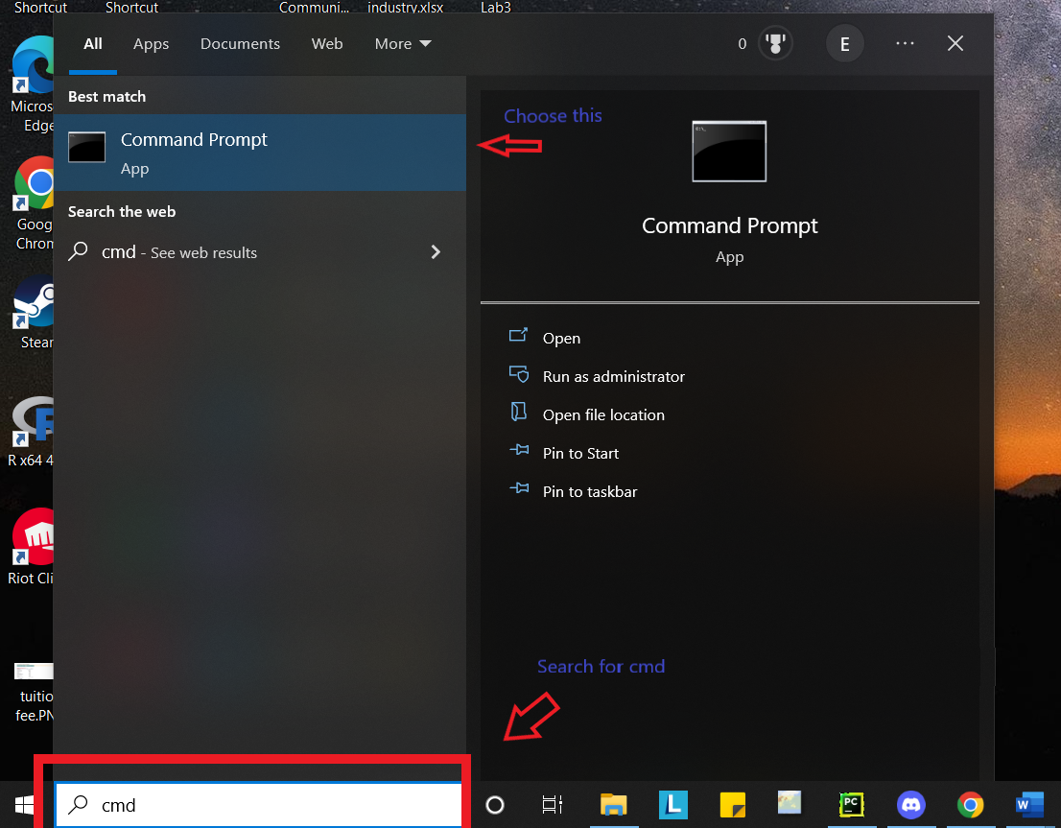STEP 1: On the search bar, look for cmd

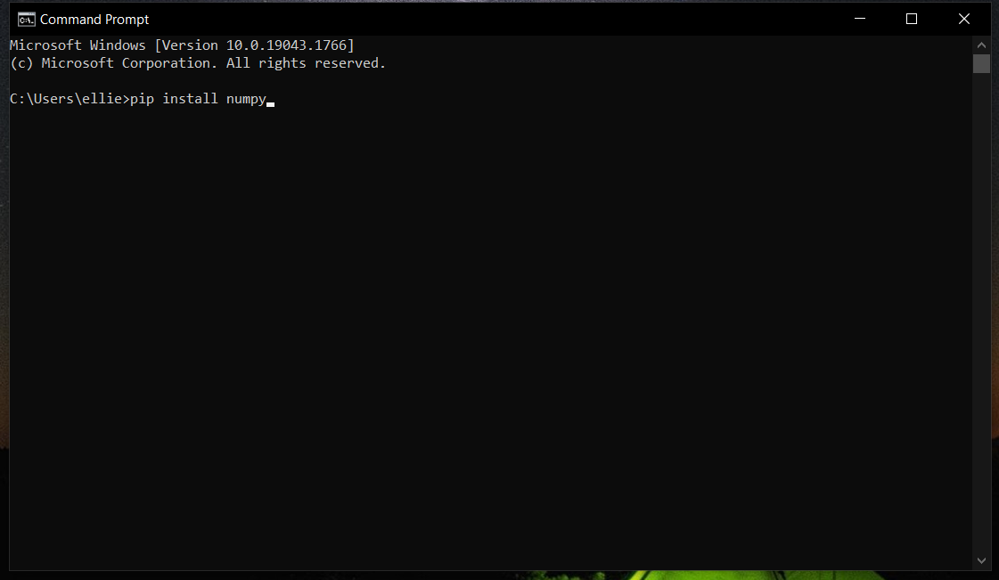STEP 2: run command: pip install <package name>. For example, to install numpy package we will run command: pip install numpy

### Cartopy

The package Cartopy requires 3 other packages, namely **proj, geos and shapely** to be installed first. Installing these with pip install could lead to error on some machine.

**To install proj and geos:**

STEP 1: Go to this link: <https://trac.osgeo.org/osgeo4w/>

STEP 2: Click on the OSGeo4W network installer link

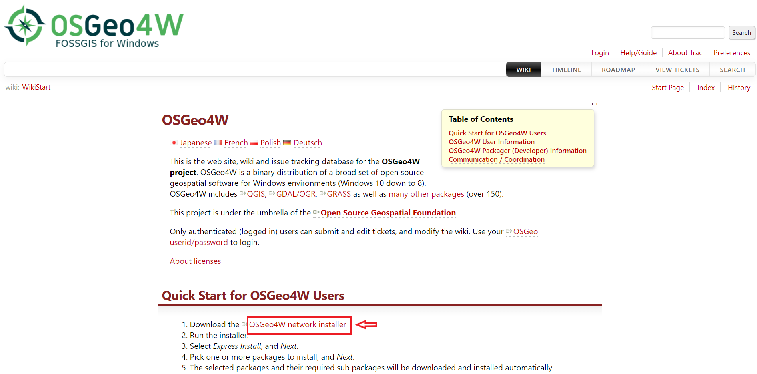

This link will download a file called osgeo4w-setup.exe



STEP 3: Right click on the osgeo4w-setup.exe file that was downloaded, and choose Run as Administrator

STEP 4: Choose Advanced Install -> Install from Internet -> All Users -> Next -> Direct Connection -> download.osgeo.org. At the end of this step we are looking at a box like this:

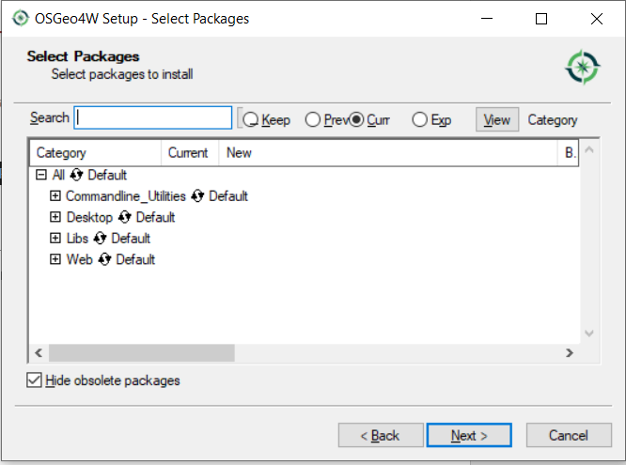

STEP 5: On the search bar, search for proj. Then click on the plus sign next to Libs to expand all options

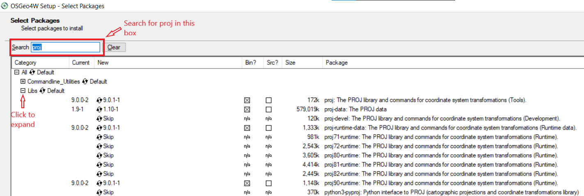

STEP 6: Click on the top 2 “skip”s until it shows the latest release version (similar to the picture below). Double check that the top 2 rows are proj package and proj-data packages respectively.

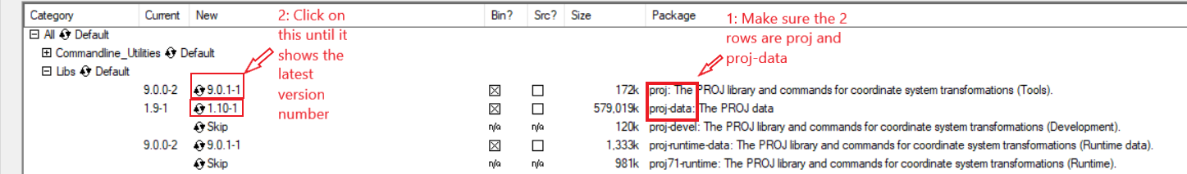

STEP 7: Back to the search bar, search for geos. Then click on the plus sign next to Libs to expand all options again

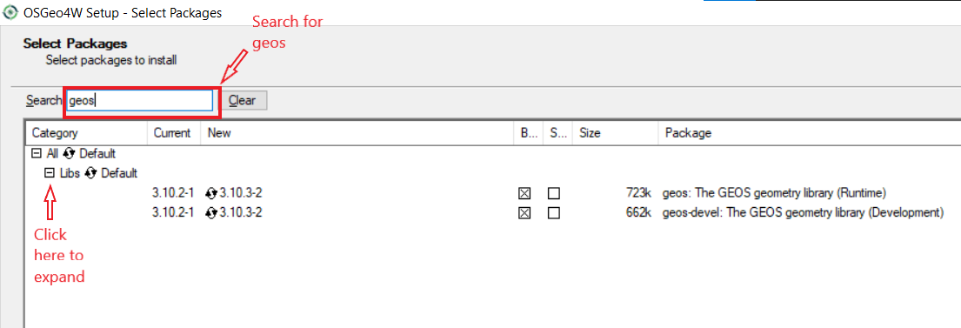

STEP 8: Click on the top “skip” until it shows the latest release version (similar to the picture below).

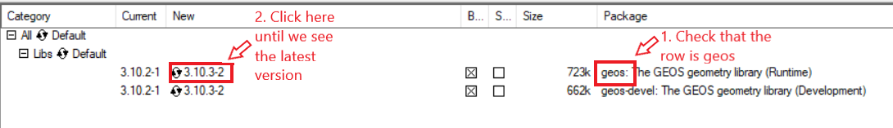

STEP 9: Click next->next. Then wait for the installation to complete

**To install shapely:**

STEP 1: we need to check for the python version we are using. This is machine dependant. On the search bar looks for cmd:

Then run command: python --version

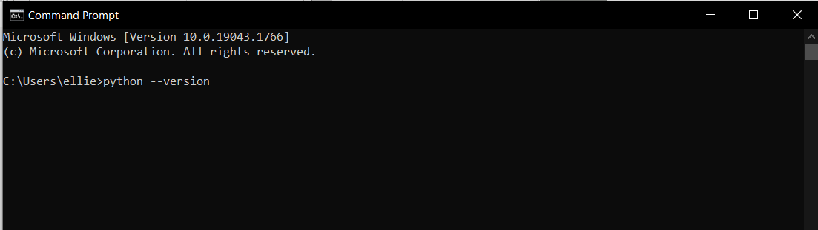

Hit enter and see what version of python we are using. In this example the python version is 3.10.1

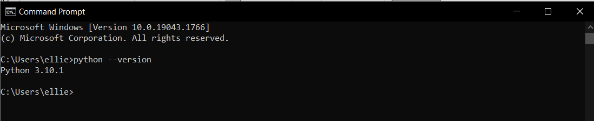

STEP 2: Go to this link: <https://www.lfd.uci.edu/~gohlke/pythonlibs/#shapely>

Then choose the corresponding version of shapely:

+ If the python version is 3.10, the corresponding link must contain cp310 (abbreviation cpython cpython 3.10). Similarly, if the python version we are using is 3.7, the corresponding link must contain cp37

+ If the machine we are using is 32-bits window, the corresponding link must contain win32.whl. If the machine we are using is 64-bits window (this is most likely the window version all computers are run on now), the corresponding link must contain win_amd64.whl

Example: Our version of python is 3.10.1 and we are using 64-bits window, then we will choose this link:

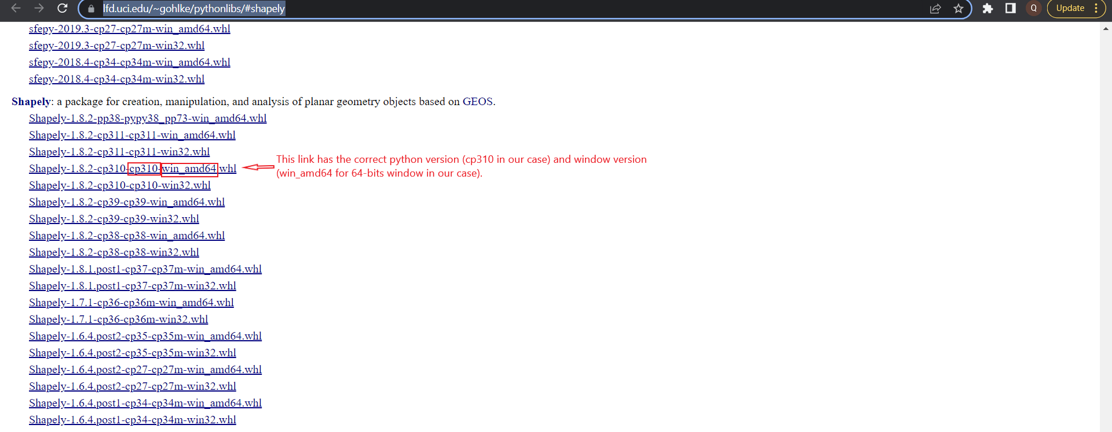

STEP 3: Move the downloaded file to the root folder. The root folder is the folder cmd shows when you first open it. In this example:

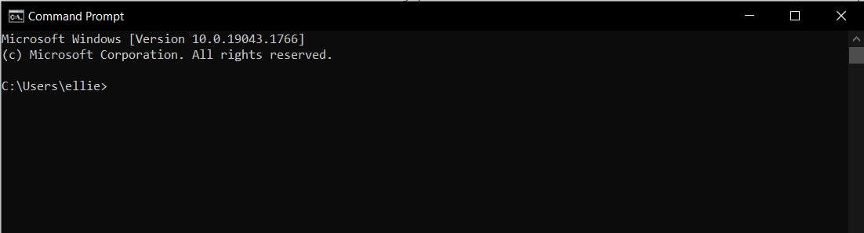

ellie is the root folder, and the directory for the root folder is C:\Users\ellie.

STEP 4: run command: pip install <shape_file_name.whl>

In this example, the command we will run is: pip install shapely-1.8.2-cp310-cp310-win_amd64.whl

**NOTE 1:** Step 3 could be omitted, but the command in step 4 must be changed to pip install \{path}\{to}\{whl}\shape_file_name.whl. However, if the directory is too long there will be error massage raised and the command will fail (this has to do with the length limit of the command in cmd). So, following all steps and do it as above is highly recommended.

**NOTE 2**: An easy way to get the file name (without re-typing it by hand) is to right click on the file and choose rename. Then press ctrl+A and then ctr+C to copy the entire name of the file. The name can now be pasted to cmd.

**Installing Cartopy**

After installing **proj, geos and shapely** packages, we can now install Cartopy

STEP 1: Go to this link: <https://www.lfd.uci.edu/~gohlke/pythonlibs/#Cartopy>

Then choose the corresponding version of Cartopy:

+ If the python version is 3.10, the corresponding link must contain cp310 (abbreviation for cpython 3.10). Similarly, if the python version we are using is 3.7, the corresponding link must contain cp37)

+ If the machine we are using is 32-bits window, the corresponding link must contain win32.whl. If the machine we are using is 64-bits window (this is most likely the window version all computers are run on now), the corresponding link must contain win_amd64.whl

Example: Our version of python is 3.10.1 and we are using 64-bits window, then we will choose this link:

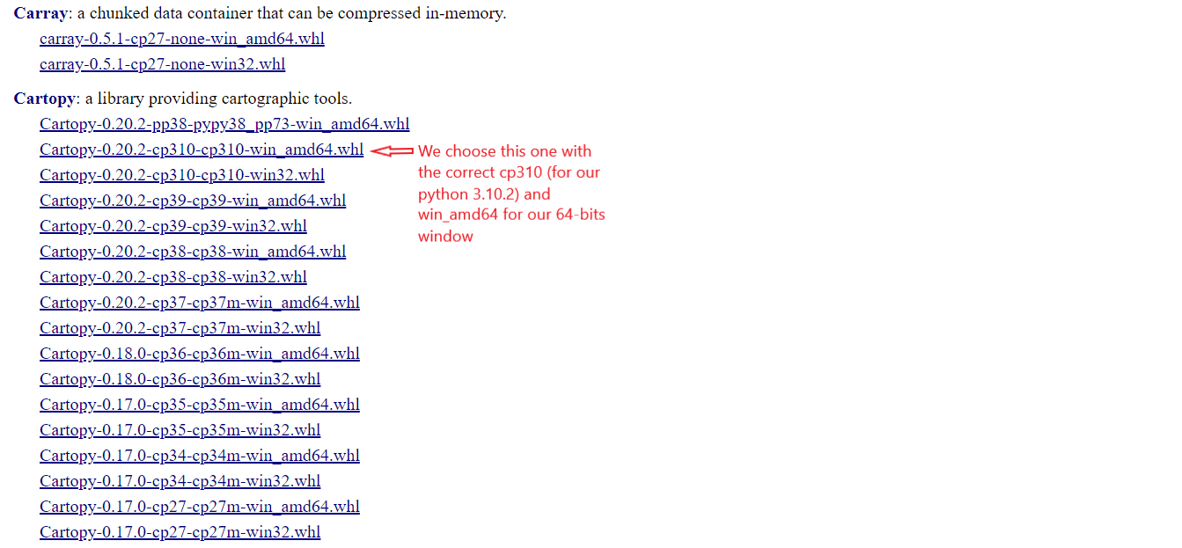

STEP 2: Move the downloaded file to the root folder. The root folder is the folder cmd shows when you first open it. In this example:



ellie is the root folder, and the directory for the root folder is C:\Users\ellie.

STEP 4: run command: pip install <cartopy_file_name.whl>

In this example, the command we will run is: pip install Cartopy-0.20.2-cp310-cp310-win_amd64.whl

# Program Running

This program is set to run at specific time, and will generate an image file at the same directory it’s in.